**APPLICATION CONTAINERIZATION**

**LAB EXPERIMENT 5**

**SUBMITTED BY:**

NITISH KUMAR SINGLA

500071913

R171218126

**SUBMITTED TO:**

HITESH KUMAR SHARMA SIR

**Docker Compose**

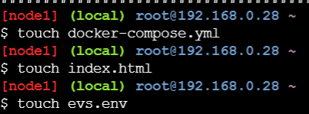

docker-compose.yml

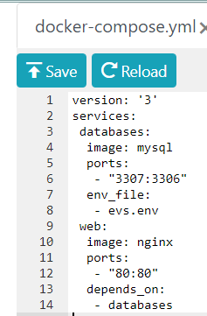

evs.env

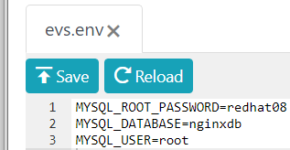

$ docker-compose up

